**VEHICLE ENTRY AND EXIT SYSTEM​**

A First Year Project Report

Submitted to the Faculty

of the

Bennett University

By

Raghav Gupta, Reet Aggrawal, Vedic Patel, Shashank Shekhar

E19CSE258,E19CSE322,E19CSE018,E19CSE098

Department of Computer Science Engineering

November 2019

Greater Noida-201310, Uttar Pradesh, India

**TABLE OF CONTENTS**

1. INTRODUCTION1

1.1. Problem Statement 1

2. Background Research 2

2.1. Proposed System 2

2.2. Goals and Objectives 2

3. Project Planning 4

3.1. Project Setup 4

3.2. Stakeholders 4

3.3. Project Resources 5

3.4. Assumptions 5

4. Project Tracking 7

4.1. Tracking 7

4.2. Deliverables 7

5. SYSTEM ANALYSIS AND DESIGN 9

5.1. Overall Description 9

5.2. Users and Roles 9

5.3. Design diagrams/ UML diagrams/ Flow Charts/ E-R diagrams 10

5.3.1. Use Case Diagrams 10

5.3.2. Class Diagram 11

5.3.3. Activity Diagrams 12

5.3.4. Sequence Diagram 13

5.3.5. Data Architecture 14

6. User Interface 15

6.1. UI Description 15

6.2. UI Mockup 9

7. Algorithms/Pseudo Code 10

8. Project Closure 11

8.1. Goals / Vision 11

8.2. Delivered Solution 11

8.3. Remaining Work 12

1. INTRODUCTION

What happens when a vehicle enters a certain premise? The answer is that the records are manually entered by the guards. Similarly, when a vehicle exits, the exit time is noted down by guards. But what if there is automatic solution available for this problem like when a vehicle enters, it is automatically entered in the database and when it exits, it is automatically removed. Our software can make this thing possible. ​

Problem Statement

* The Problem with the current manual entry system is that guards take a lot of time to make the entry of vehicle which consumes some time and moreover, leads to commotion most of the time.
* Secondly there is no way to determine that for how long, the vehicle is in the premises. Some vehicle which stay for unusual duration can raise suspicions.
* Also, sometimes parking space is full but the entry of vehicles is on. The situation would get clumsy.

1. Background Research

How to convert image into text using tesseract OCR

Proposed System

1. Our software can ease down the vehicle entry work by taking down details automatically
2. Also, a limited time duration can be set after which the vehicle will become flagged and the same notification will be sent to guards to take appropriate actions.
3. Similarly, when the vehicle exits the university, it will be automatically removed from the database.
4. Also, this software can be used to determine whether there is enough parking space.
   1. Goals and Objectives

Table 1: Goal and Objectives

|  |  |
| --- | --- |
| **#** | **Goal or Objective** |
| 1 | In future, our software can be used in services like paid parking which are time bounded so during the exit of the vehicle, the amount to be paid will be shown automatically |
| 2 | Our software can also be used in highway toll gates where a user can himself / herself can access the booth without human interaction. |
| 3 | Our software can be used in office buildings and schools to ensure safety and to make sure that the parking is in order, and the premises is not overcrowded. |

1. Project Planning

This required extensive planning and inputs from various mentors and seniors.

1. First, a user will capture the image of the number plate.
2. Then the image clicked by the camera would be converted into text using tesseract OCR.
3. The text would be stored in the database which would be created by our team
4. Then the vehicle would get monitored the entire time it is in the premises.

Project Setup

1. The software shall recognize the vehicle by converting the image of number plate in text
2. The software shall alert the guards when a vehicle stays in the premises for long period of time.
3. The software shall enter the data into a database when the vehicle enters and shall remove that data when the vehicle exits the university.
4. Also, the software will tell the time spent in the premises (will be useful in future updates)

Table 2:

|  |  |
| --- | --- |
| **#** | **Decision Description** |
| 1 | Windows 10, Python, Google Colab, Git, etc. |

* 1. Stakeholders

Table 3:

|  |  |
| --- | --- |
| **Stakeholder** | **Role** |
| Dr Anurag Goswami | Mentor |
| Raghav Gupta | Team Member |
| Vedic Patel | Team Member |
| Shashank Shekhar | Team Member |
| Reet Aggrawal | Team Member |

* 1. Project Resources

Python, Tesseract OCR

* 1. Assumptions
  2. We Assume that our project would be completed in 2 months
  3. We assume that the image to text conversion would be accurate
  4. We assume that the camera can easily click the picture of the car

Table 5:

|  |  |
| --- | --- |
| **#** | **Assumption** |
| A1 | We Assume that our project would be completed in 2 months |
| A2 | We assume that the image to text conversion would be accurate |
| A3 | We assume that the camera can easily click the picture of the car |
|  | |

1. Project Tracking
   1. Tracking

First, we divide the work among our team mates then we always keep asking the status of the work which has been completed.

Table 6:

|  |  |  |
| --- | --- | --- |
| **Information** | **Description** | **Link** |
| Code Storage | Project code will be stored in github repository. | https://github.com/raghavguptaeng/p1sem1_eb04.git |
| Bug Tracking | Bug tracking will be done manually |  |
| Project Documents and Assignments | Weekly reports, specification and design documents, etc. will be stored in our github repository. | https://github.com/raghavguptaeng/p1sem1_eb04.git |
| Testing | We will test our software manually |  |

* 1. Deliverables

Table 11: Deliverables

|  |  |
| --- | --- |
| **#** | **Deliverable** |
| 1 | Code |
| 2 | Test and test results |
| 3 | Final report (final PowerPoint presentation, 3 minute video, and final sprint) |

1. SYSTEM ANALYSIS AND DESIGN

This section describes in detail about the design part of the system.

* 1. Overall Description

This project is been made to solve the problem of finding parking places

In this project, a user must click the picture of the number plate of the vehicle and then the software would convert the image into text automatically. The image to text conversion is done using tesseract OCR. The text is then stored in a database which was developed using python.

* 1. Users and Roles

Table 12:

|  |  |
| --- | --- |
| **User** | **Description** |
| User at entry | A guard would capture an image of the number plate and then allow the vehicle with a specific time limit inside if there’s a parking space left. If not, he/she will take appropriate measures. |
|  |  |
|  |  |
| User at exit | This person will remove the vehicle from the current database just by capturing the license number. |

* 1. Design diagrams/ UML diagrams/ Flow Charts/ E-R diagrams
     1. Use Case Diagrams

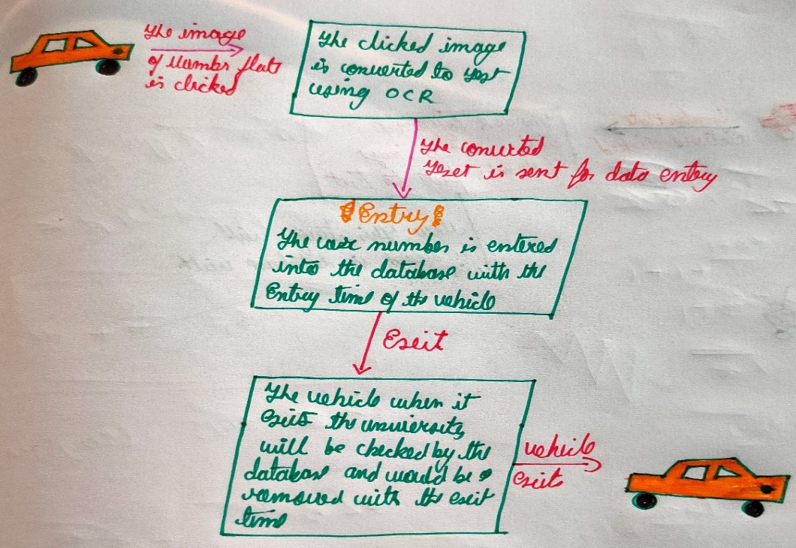

* + 1. Class Diagram

Outim

This function will handle all queries related to vehicle exit.

Intim

This function will handle all the queries related to vehicle entry.

Menu

This function will display and accept options from the user.

Countvehin

This function will give us the no. of vehicles that are inside the premises.

* + 1. Activity Diagrams

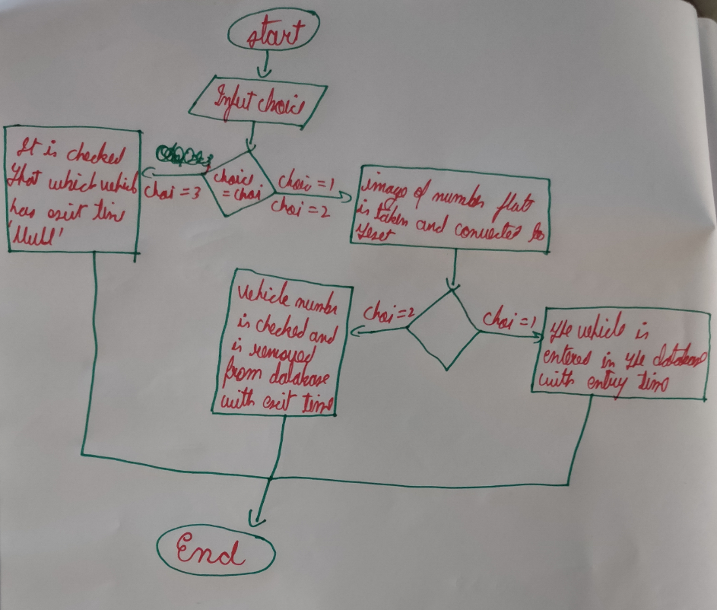

* + 1. Sequence Diagram

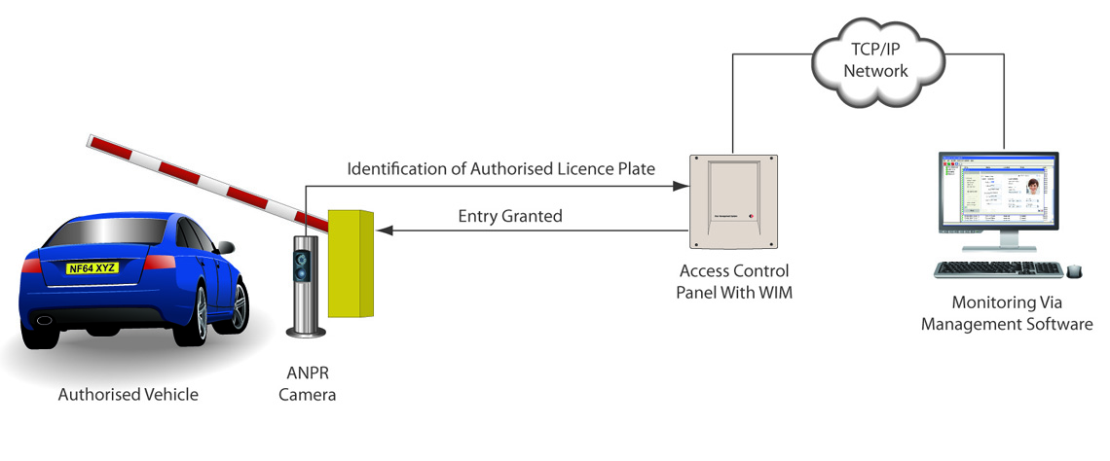

1. User Interface
   1. UI Mockup

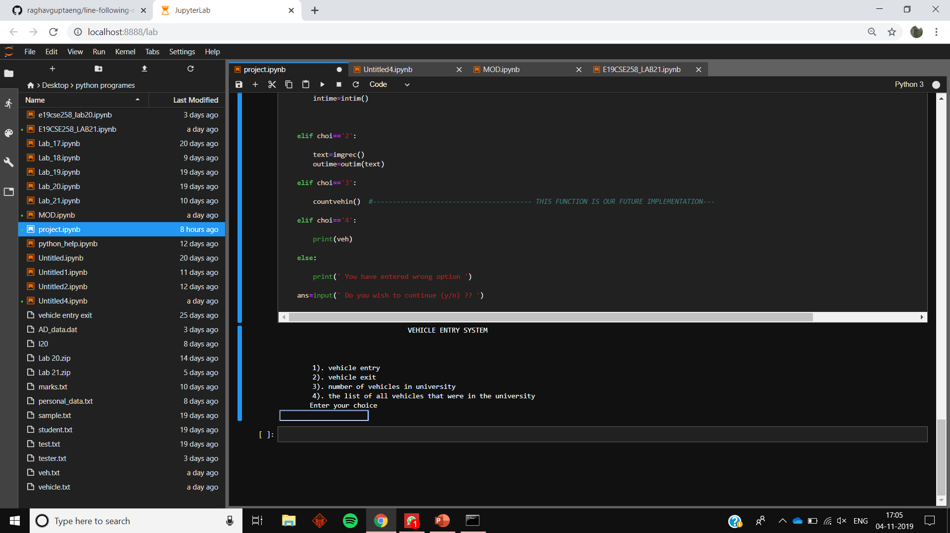

Figure 6

1. Algorithms/Pseudo Code
2. 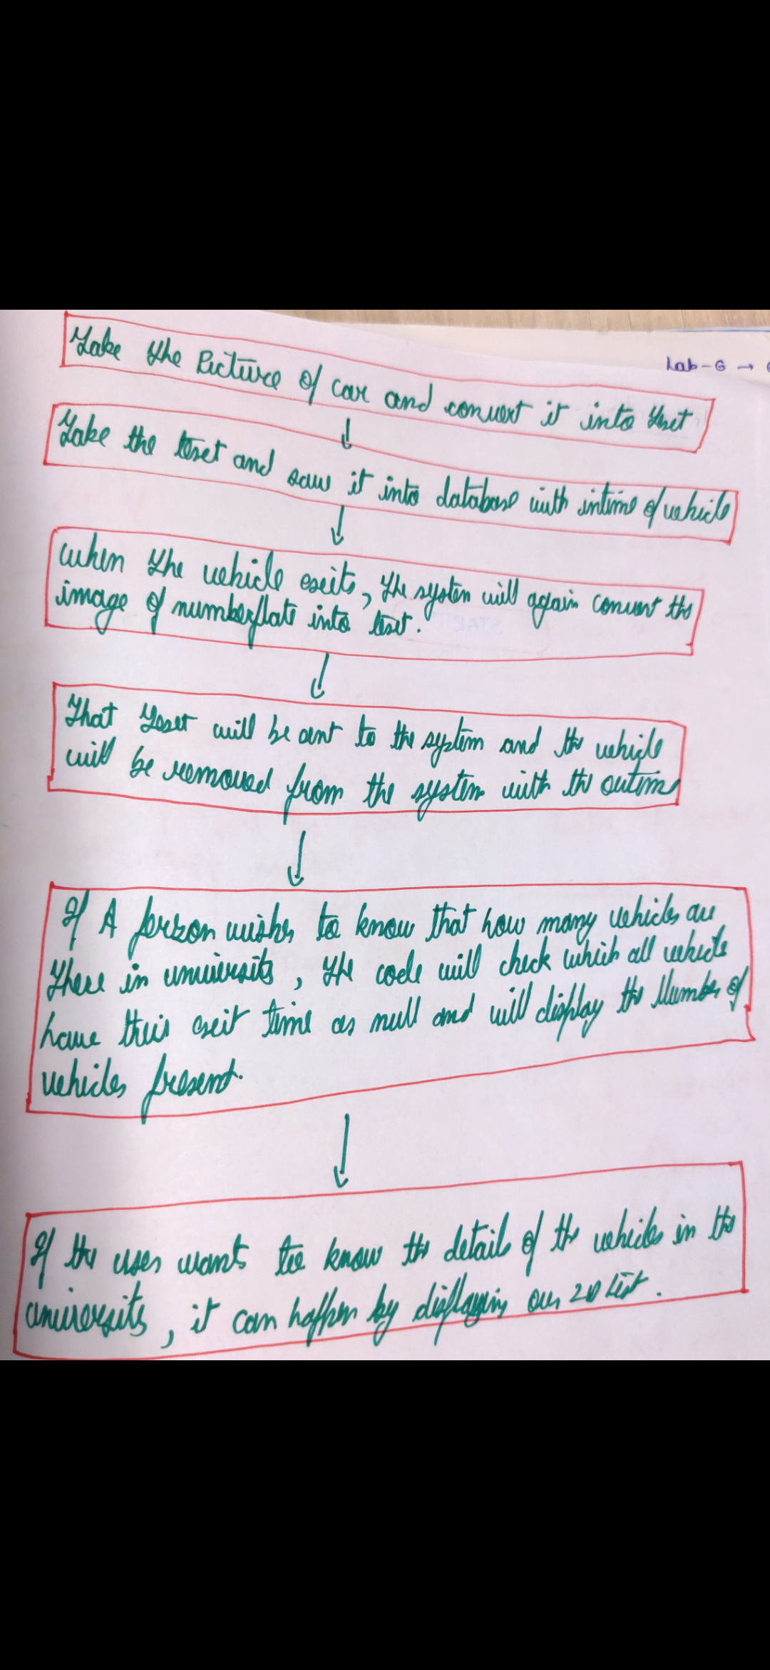

8.Project Closure

This section elucidates the overall lookup at the project and some of the future works that may enhance the solution.

* 1. Goals / Vision

In future, our software can be used in services like paid parking which are time bounded so during the exit of the vehicle, the amount to be paid will be shown automatically.

Our software can also be used in highway toll gates where a user can himself / herself can access the booth without human interaction.

Our software can be used in office buildings and schools to ensure safety and to make sure that there is enough parking space, and the premises is not overcrowded

* 1. Delivered Solution

We started our project with a vision that our software will make the entry and exit of a vehicle in the premises like university fully autonomous. We succeeded in making our project to work on our expectations but still it has some problems left on which we will have to work more. Our project uses python language to use artificial intelligence to convert image of number plate into text and then store that information in a database. On the exit of vehicle, it will again sense the vehicle and make it exit from the database. It has other functions like telling how many vehicles are currently there in the premises and also track records on every one of them.

* 1. Remaining Work

1. We can Improve image to text conversion code by adding machine learning to it so that when the camera clicks the picture of the vehicle it can identify the vehicle whether it is a car, bus, truck, bike etc.
2. We can improve the project so that it could perform well even in foggy and rainy condition.
3. We can fix the code so that even it can convert blurry image to text easily.
4. We can provide hardware integration in our project